Low Level Design

Food Recommendation System

Written By Showmick guha paul

Contents

1. Introduction

1.1. What is Low-Level design document?

1.2. Scope

2. Architecture

3. Architecture Description

3.1. Data Description

3.2. Data Pre-processing

3.3. Model Building

3.4. Data from User

3.5. Output

3.6. Deployment

What is Low-Level design document?

The goal of LLD or a low-level design document (LLDD) is to give the internal logical design of the

actual program code for Food Recommendation System. LLD describes the class diagrams with the

methods and relations between classes and program specs. It describes the modules so that the

programmer can directly code the program from the document.

1.2. Scope

Low-level design (LLD) is a component-level design process that follows a step-by-

step refinement process. This process can be used for designing data structures, required software architecture, source code and ultimately, performance algorithms. Overall, the data organization may be defined during requirement analysis and then refined during data design work.

2. Architecture

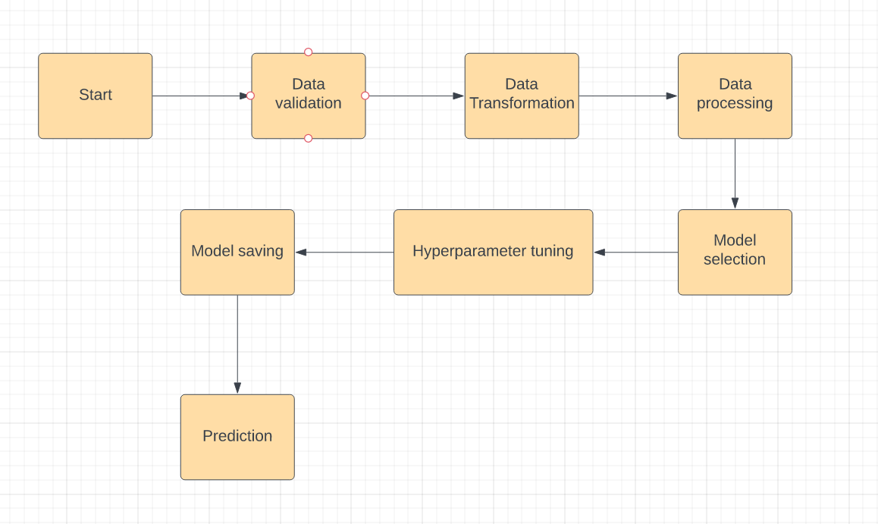

3. Architecture Description

3.1. Data Description

It is a publicly available Bigmart dataset. This dataset contain csv file.

3.2. Data Pre-processing

Data Pre-processing steps we could use are Null value handling, stop words removal, punctuation removal, Tokenization, Lemmatization, TFIDF, Imbalanced data set handling, Handling columns with standard deviation zero or below a threshold, etc.

3.3. Model Building

After data is prepare we will find the best ML model .ML model will be passed with the best parameters.

3.4 Data from User

Here will collect data from Item_weight,item visivility, item type,Item MRP, Outlet identy, Size of outlet, location of outlet, type of outlet,food fat condition.

3.5 Output

After giving the data model will predict and give output.

3.17. Deployment

We will be deploying the model in local host.